- Find a unique 4 bar mechanism.
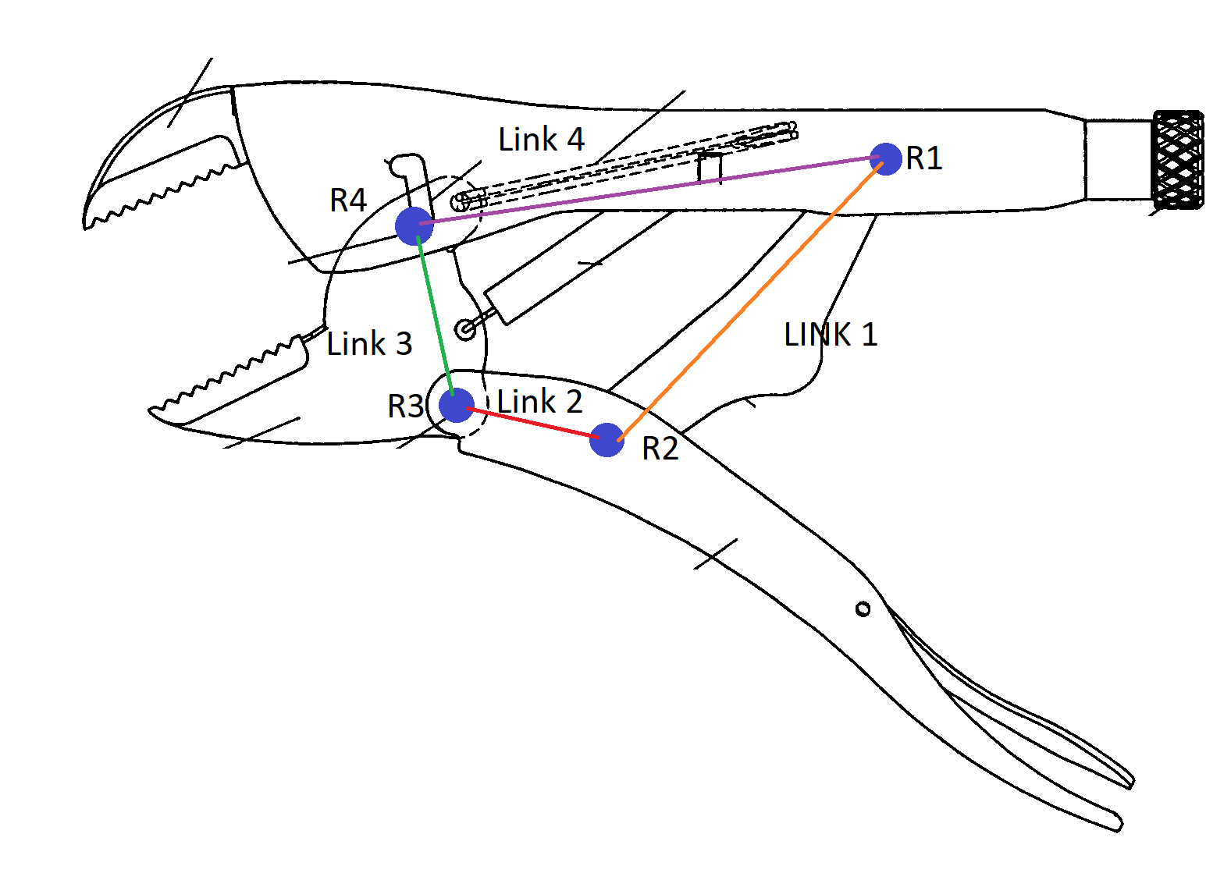
This is an extremely complicated piece of machinery known as a locking plier, or “Vice Grip”.
- How many DOF do the following joints have:
- Knee--------1 (rotational)
- Ankle-------3(ball socket)
- Shoulder—3(ball socket)
- Hip----------3(ball socket)
- Knuckle----2(2 rotational)
Note: Made mistake when drawing. (R3 is also a multi-Joint, the ground also counts as an additional link, and L3 and the ground counts as a ½ DOF.)

- Calculate the mobility of the parts in the picture
$$DOF=3\left(L-1\right)-2*J_{1}-J_{2}$$
- $DOF=3*(6-1)-2*7=0 DOF$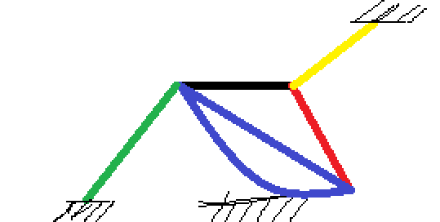

- $DOF=3*(3-2)-2*2-1(from roll-slide)=1 DOF$

- Identify the items in the figure from the previous problem as mechanisms, structures, or preloaded structures.
  - 0 DOF=Structure
  - 1 DOF=mechanism
- Determine grashof

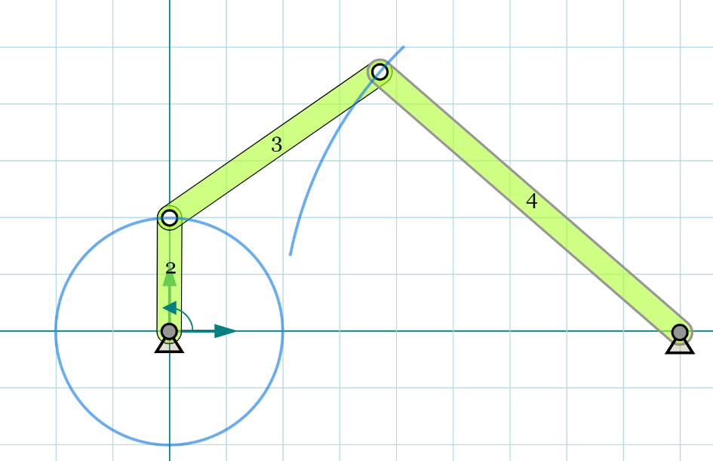
$S+L<=P+Q→2+9≤4.5+7→11≤11.5 is true, thus is Grashof$ Class I, GCRR

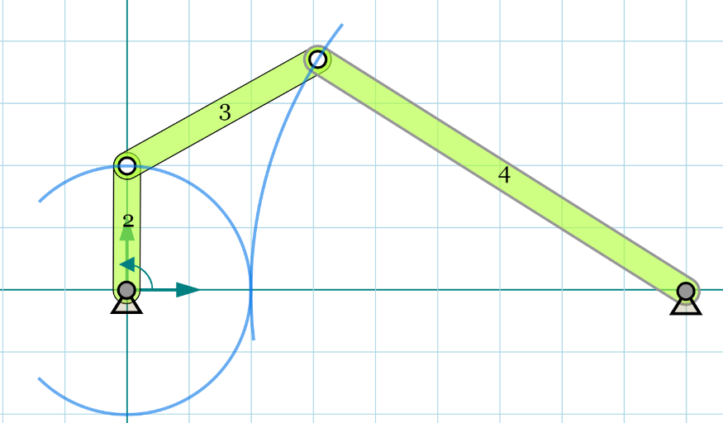
$S+L<=P+Q→2+9≤3.5+7→11≤10.5 is false, thus is NOT Grashof$ Class II

  - 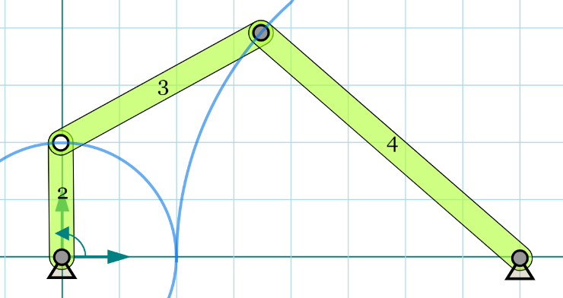
$S+L<=P+Q→2+8≤4+6→10≤10 is true but is Grashof special case$ Class III

